Homework 4
Due on April 3rd, 2018
Xiongming Dai

Problem 1:
A hidden layer of size 20 is used to test the performance of RBF network for different spreads. The training set and testing set are same for different spreads. The MATLAB code is
%% Homework 4 Problem 1: use RBF NN to achieve the specified mapping
% f(x) = cos(3*x)*sin(2*y) , -1<=x<=1, -1<=y<=1
clc;
clear all;

%% generate the training data
rand('state',0);
randn('state',0);
N_train=300;
Xtrain=unifrnd(-1,1,2,N_train);
Ttrain=cos(3*Xtrain(1,:)).*sin(2*Xtrain(2,:));

% generate the test data
N_test=100;
Xtest=unifrnd(-1,1,2,N_test);
Ttest=cos(3*Xtest(1,:)).*sin(2*Xtest(2,:));

% train the RBF NN network
goal = 0;
spread = 1;
MN=20;
DF=5;
net = newrb(Xtrain,Ttrain,goal,spread,MN,DF);

% test the network
Tnet = sim(net,Xtest);

% evaluate the performance of the network
mse_test = mean ((Ttest-Tnet).^2);

And the results using testing data set are shown below.

Spreads | MSE
1 | 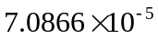
2 | 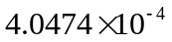
3 | 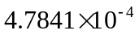
5 | 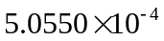
0.9 | 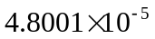
0.6 | 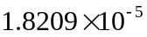
As you can see from the table, the spread plays an important role in the performance of RBF network. 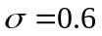 achieves the best result among the six trials of different spreads.
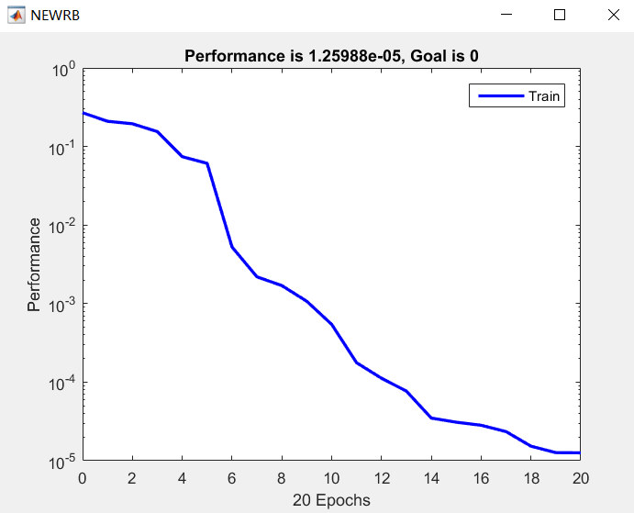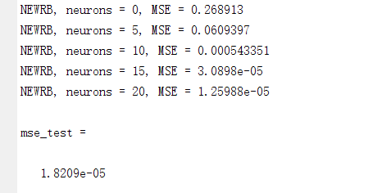

Problem 2:
- Understand the data. Visualize the data, we can find the figure shown as follows:
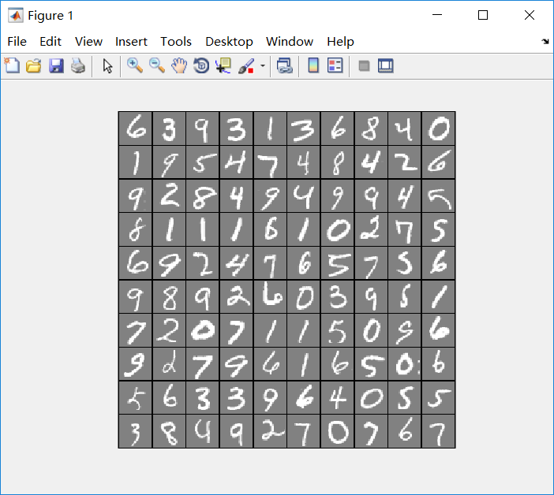
Check the dimension of input and targets, we find the dimension of input is 60,000x784, and the dimension of targets is 60,000x1, which means we have 60,000 samples for training, each sample is described by 784 elements. They are in correct dimensions. Please notice that in order to improve the accuracy of our model, we change the dimensions for our second optimization to 5,000x400 and 5,000x1,respectively. It is easy for us to find this element is from 0 to 1. Therefore, the data have been normalized.
- Start with a random model:(a)the optimization model is based on the gradient descent algorithm with cross-entropy, therefore, the activation function is logistic regression function. (b)the learning rate is 0.1.(c)the number of hidden layers is 25. The number of neuron of input layer is 400. The number of labels is 10, it is 0,1,2,...,8,9.
- Train the model. We train the model with 50 iterations with gradient descent algorithm, in order to eliminate over-fitting, we introduce regularization and the regularized parameter is lambda in Matlab.
- Although we introduce the mechanism of regularization, the accuracy is not high. So we try to decrease the dimension of the input. It works!!!Finally, we got good accuracy.

